EverUpdate Manifest Administration Web Console User’s Guide

Table of Contents

Introduction to Manifest Administration 1
User Interface Overview 2
User Roles 2
Navigation Bar 2
Main Body Panel 2
Basic Manifest Walkthrough 3
How-To’s 4
Login 4
Change Your Password 4
Create a Company 5
Create a User 5
Create an Application 6
Create a Manifest 6
Create Manifest Items 7
Assign Manifest Items 9
Page Details 11
Home Page 11
Upload Page 12
Assign Page 13
Manage Items Page 14
Manifests Page 15
Applications Page 16
Users Page 17
Companies Page 18

Introduction to Manifest Administration
EverUpdate Consists of a Client Library, in the form of .Net assemblies, and hosted services for managing and delivering patch and update Manifests and Manifest Items, which may be files.
As illustrated in Figure 1, you manage Manifest definitions via a remote web browser that accesses the EverUpdate Administration console. You define Manifests which contain Manifest Items. The Manifests and related Items describe, for a given application, the patches or updates that are available and define their contents. Manifest Items currently consist of Registry Entries and Files. Files can be executables that should be run during the patch process, custom .Net Installer assemblies that should be invoked, or simple files that should be placed on the hard drive or which replace existing files, DLL’s, assemblies, etc. Files can optionally be defined as locked files, in which case they replace existing locked files during the next reboot.
The download of Manifests and Manifest Items is performed automatically by the Client Library via HTTP requests to the EverUpdate Host Web Service.

Figure 1

User Interface Overview

User Roles
Users of the EverUpdate administration console are assigned one of three roles which determine their capabilities:
- User – Regular user who can create and manage Manifests and Manifest Items.
- Admin – Company administrator who has all the capabilities of a User, and also has the ability to create and manage users within their own Company.
- SysAdmin – System administrator who has all the capabilities of an Admin, but can create and manage Companies, and can manage all Users across all Companies.

Navigation Bar
After you login to the EverUpdate admin site, you will see the Home page of the administration console, which consists of the top navigation bar, and the home page body, which displays some basic statistics for the user you have logged in as.
The top navigation bar is the primary means of navigation within the admin console. It also displays the current user in the upper-right corner.

Certain menu options are only visible by certain classes of user. Ordinary Users will not see the Users or Companies options. Admin users will not see the Companies options. SysAdmin users will see every option.

Main Body Panel
The main body of the console will display the panel appropriate to the top navigation option you select. The Name of each console panel will be displayed in the upper left of the main body.
When you first login, you will see the Home page panel. This panel displays your company and user information, as well as some statistics related to the Manifests that have been defined in the system.

Basic Manifest Walkthrough
As mentioned above, creating a patch or update for your client application involves defining Manifests which contain Manifest Items which consist of Registry Entries executable, .Net Installer assembly, or basic File types.
This walkthrough will describe the process for creating a simple, hypothetical patch. It refers to various use cases describe in the How-To’s section.
Let’s assume that you have an application, “Widget.exe”, which uses the Log4Net logging framework, and which you have update-enabled by embedding the update support provided by the EverUpdate Client Library included in the SDK. Assume your company, as defined in the EverUpdate config.bin file deployed with the executabl, is “Acme, Inc.”, the application name is “Widget 1.0”, and the current version is “1.0”.
Applications using Log4Net typically include the log4net assembly in their project, as well as a Log4Net configuration file named according to the application. In this case, assume it is Widget.Log4Net. In the simplest case, this file is placed in the working (run) directory of the executable. Now let’s assume that you want to increase the logging that Widget.exe performs on each machine where it is installed. To do this, you create a new Widget.Log4Net file, which you need to deploy to all the machines where your application. To do this, you will need to define a new Manifest containing a single item; the new Widget.Log4Net file. Assume you want the version number of Widget.exe, following application of the patch, to be “1.0.1”.
The steps you would follow to define the patch Manifest via the Manifest Administration web console are as follow:
- If you have purchased and installed an Enterprise version of EverUpdate and the associated administration site, login to the web console as the default Site Admin, and create a new Company and a User in that company, then logout and back in as the new user. (See the Create a Company, and Create a User How-To’s to create a Company and User.)
- If you are a BETA user of the EverUpdate SDK, a Company and User have been created for you automatically when you registered the product based on the registration information you provided. You should have received an email containing your login credentials.
- Create an Application with the Name “Widget 1.0” as described in the Create an Application How-To.
- Create a Manifest as described in Create a Manifest. Name the Manifest “Logging Update”, give it any description, and set the Version to 9.9 for now in case any Widget.exe’s (which report their version as 1.0) check for updates while we’re in the process of defining the Manifest (we don’t want them to get it while it’s half-defined). Set the Final Version to 1.0.1.
- Go to the Upload panel, as described in Upload Manifest Items.
- Create a Category folder under the root of “Acme, Inc.”, called “Widget”, and create a folder under that on called “Configuration Files”.
- Browse your local hard drive for the new Widget.Log4Net file and add it to the upload list. Make sure the “Configuration Files” folder is selected and upload the file.
- Switch to the Manage Items console (Manage Manifest Items), click on Widget.Log4Net, specify “.\” as the target directory and “1.0.1” as the Version.
- Switch to the Assign console (Assign Manifest Items). Choose the Manifest you created in (3), then assign the item you created in (7).
- Return to the Manifest panel, select the “Logging Update” Manifest, and set the Version to 1.0 to indicate that the patch should be applied to Widget.exe’s which report their version as 1.0.
- That’s it! Your manifest is now available for download by client applications. When Widget.exe performs an update check, it uses the Company, Application and Version properties from its config file to check for updates. The EverUpdate web service compares those values to the manifests available and finds that the “Logging Update” Manifest is available. The client could then request to download and apply it.
See the EverUpdate Client SDK Developers’ Guide for more information on the specifics of how to configure or update-enable a client application by incorporating the EverUpdate client library.

How-To’s

Login
In Internet Explorer, navigate to the home page URL, http://{host}/EverUpdateAdmin/Welcome.aspx, where {host} is the hostname (and, if necessary, port) where the Admin website is hosted. For example, http://www.practical-apps.com:81/EverUpdateAdmin/Welcome.aspx
Your will be prompted to login. Enter your email address and password. If you have purchased and enterprise license of EverUpdate and set up your own host, the initial login is:
User: SysAdmin@yoursite.com
Password: sysadmin

If you registered for, and downloaded, the BETA, you should have received an email containing your user login credentials.

If this is the first time you are logging in, you should change your password to something else before continuing.

Change Your Password
From the Home page, click the “Change Password” button at the buttom of the panel.

Enter your password twice, then click “Save”. Passwords must be at least 8 characters long.

Create a Company
To create a company, select Companies from the top navigation bar:
Click the New Company icon:
Enter the Company Name, the Email address of the primary contact, and any additional Contact Info you would like to retain regarding the company, then click Save.
Only SysAdmin users can create new Companies.

Create a User
To create a new User, select Users from the top navigation bar:
You must create the Company a user belongs to before creating the user.
Click the New User icon:
Enter the User’s Email address (which will be their login ID).
Select the company they belong to in the Company drop-down. Admins will only see their own Company. SysAdmins will see all companies.
Assign a password, entering it twice for verification.
Select their role. Roles can be SysAdmin, Admin, or User. Only SysAdmins Can create other SysAdmins or Admins. If your update server is being hosted by Practical Apps, you will not be able to create SysAdmin users, this role is reserved for EverUpdate personnel only.
Enter the User’s First Name, Middle Initial (optional) and Last Name.
Click Save.
Only Admins or SysAdmins can manage Users.

Create an Application
Before you create a Manifest and Manifest Items, you need to create an Application. You will then define Manifests, containing Manifest Items, which define patches or updates that can be applied to your application.
To create an Application, select Applications from the top navigation bar:
Then click the New Application icon:
Specify the Name of your application. This is the same name that you will define in the EverUpdate config file you include with your application.

Enter a Description of your application. The Description should briefly describe the applications and is purely for the convenience of users.
Click Save.

SysAdmins can manage Applications for any Company.
Admins can manage Applications for their own Company.

Basic Users do not have Application management rights.

Create a Manifest
A Manifest defines an update or patch that can be applied to a given version of a given application. When an EverUpdate-enabled client application checks with the server for available updates, it passes the Application name and Version defined in its config file. The server uses these to query the Manifest table to identify the candidate updates that are available to be applied to the client app.
To create a Manifest, select Manifests from the top navigation bar:
Then click the New Manifest icon:
Enter the Name of the Manifest. Depending on the prompt settings you define for your application and whether you implement custom prompts, the Name may be displayed to end-users during the update process. You should therefore give some consideration to the naming convention you use.

Select the Application that the Manifest applies to in the App drop-down box.
Enter a descriptions of the Manifest. This may also be displayed in various prompts during the update process.
To specify that a reboot is required after application of the update defined by this Manifest, check the Require Reboot box.
Enter the Application Version that the update defined by this Manifest can be applied to, then click Save.

Create Manifest Items

Manifest Item Types
Manifest Items can be of five types:
- File – A file that should be placed on the file system of the client app. Files may include DLL’s, assemblies (the Assembly type refers to an Installer Assembly), images, .ini files, etc. Basically, any file you want to deploy or replace on the client machine.
- Locked File – Locked File is like File, accept that it can be used to replace files that may be in use on the client (reboot is required for the file to be swapped into place).
- Assembly – Refers to an Installer Assembly complying with the .Net Framework Installer support. Assembly installer files will be invoked during the update application process, enabling you to perform more robust actions as part of an update
- Run – Run files will be executed during the update process. They may be batch files, or executable files.
- Registry Entry – A Windows registry entry that should be created or updated.

The first four types require that you first upload the file. You then set its attributes, including which type of Manifest Item it should be treated as.
The last type, Registry Entry, consists purely of metadata (the registry entry location, type and value), so there is no requirement to first upload a file before creating one.

Upload Manifest Items
To create the first four types, you first need to upload the files. To create Registry Entry Manifest Items, skip the upload process and go directly to Manage Items.
This is done via the Upload panel, illustrated in Figure 2, which you reach by selecting Upload from the top navigation bar:
- First, select the Category where you want to place the files. Categories allow you to organize your files into folders in some way that makes sense to you. You may, for example, choose to create a folder for DLLs and another for executables.
Prior to uploading file, you may also choose to create (or delete) Category folders to place them in. Use the Category folder create and delete icons:
- After selecting the target Category, click the Browse button to browse your hard drive for files to upload. You’ll see the usual Windows file dialog box and you select one or multiple files. Select the file(s) and click Open.
- The files will be added to the list of files pending upload. If you need to, re can remove files from the batch via the Remove Selected or Remove All buttons.
- Once you’ve selected all the files you want to upload to the selected Category, click Upload.
- The Upload progress will be indicated in the status panel.
- Once the upload is complete, the screen will refresh and the files will now appear in the contents frame for the selected folder.

Figure 2
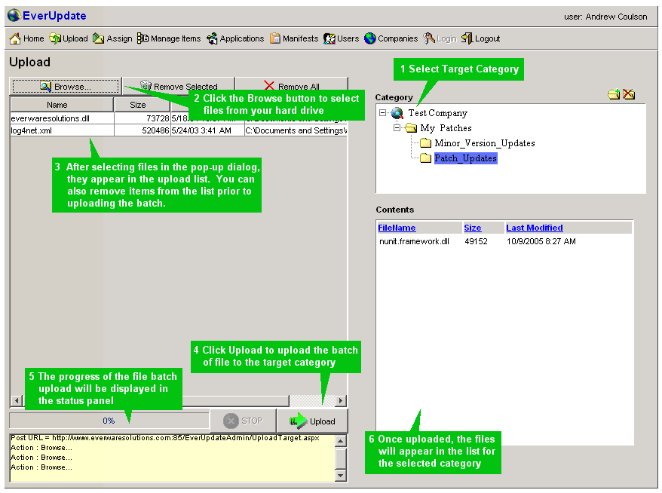

Manage Manifest Items
Before assigning your Manifest Items to your Manifest, you need to set some properties of the Manifest Items. Select Manage Items from the top navigation bar:
Next, select the Category folder which contains the item(s) you want to edit. The lower pane will display the content of the folder – select one you want to edit and the details will be displayed in a panel to the right.
Select the Type of the file. In this example, we have indicated that log4net.dll is a LockedFile, since it is an assembly that will already be present and could be in use by our application at the time of the update process. We also specify the target location, relative to the executable performing the update, the Version, and the SCM Version (the two Version fields are informational only). We would specify Install Args if we had selected Run or Assembly as the Type.

Entries of Type: Registry do not have files associated with them. A Registry Item is created from the Manager Items panel by selecting the Category that should contain it, then clicking the New Registry Entry icon:
The RegistryEntry details pane will be displayed on the right. Enter a descriptive name, the full path of the Key you want to create or update within the registry, and the value. The Registry Key must begin with one of the hive abbreviations; “HKLM”, “HKCU”, “HKCR”, “HKCC”, “HKU”. The Value must begin with the the entry type (“REG_MULTI_SZ”, “DWORD”, “REG_BINARY” or “REG_SZ”), followed by a comma, followed by the value

Assign Manifest Items
To assign Manifest Items to a Manifest you have created, click on the Assign button on the top nav bar:
On the right, above the Manifest contents pane, select the target Manifest you want to assign items to.
In Category pane, select the Category containing items you want to assign to the Manifest. The Available Manifest Items pane will display the contents of the Category folder.
In the Available Manifest Items pane, select one or more Items you want to add, then click the ‘Assign to Manifest’ icon:

The Manifest contents pane will be updated to reflect the added Items.
Note that one Manifest Item can be assigned to multiple Manifests, so if you have shared components that are used in multiple applications, you can upload them just once, then assign them to multiple update Manifests.

Page Details

Home Page

Upload Page

Assign Page

Manage Items Page

…

Manifests Page

…

Applications Page

Users Page

Companies Page

